SQL JOINS
Agenda
- Introduction to Joins in SQL
- Types of Joins in SQL
  - Inner Join
  - Outer Join
    - Left Join
    - Right Join
    - Full Join
  - Cross Join
  - Self Join
  - Delete Join
  - Update Join
Introduction to Joins in SQL
The SQL Join clause is a powerful tool used to combine data from two or more tables in a relational database. When data is stored across multiple tables, typically to maintain a normalized database structure, joins allow you to retrieve relevant records by combining fields from these tables based on a related column, often through the use of foreign keys.
A join connects rows from different tables by using a condition that defines how the tables relate to each other. This condition is often a comparison between columns, commonly using primary keys and foreign keys to link tables. However, joins can be used to compare columns using other types of operators as well.
Join Predicate
The join predicate is the part of the JOIN clause that specifies the condition under which rows from two or more tables should be combined. It typically uses comparison operators like:
- =, <, >, <=, >=, <>, !=
- BETWEEN, LIKE, IN, and NOT.
This predicate is usually specified in the ON clause of a join, where you define the relationship between the tables.
Key Features of Joins
- Flexibility: Joins allow you to combine tables in various ways, depending on how the data is structured and how you need to retrieve it.
- Multiple Tables: You can use joins to query more than two tables at once, which is useful when working with complex database schemas.
- Comparison Operators: You are not limited to equality (=) in the join condition; you can use other comparison operators and conditions to specify more complex relationships between the tables.
- No Storage: When you retrieve data using a join, the resultant table (i.e., the combined view of data from multiple tables) is displayed but not physically stored in the database.
Syntax
The basic syntax for a join in SQL is as follows:
SELECT column_name(s)
FROM table1
JOIN table2
ON table1.column_name = table2.column_name;
This syntax is the foundation of all SQL joins, regardless of how many tables are involved or how complex the join conditions become.
Joins are essential for working with related data spread across multiple tables in a relational database. They enable efficient retrieval and manipulation of data by combining rows based on defined relationships, providing flexibility and control over how records from different tables are combined.
Dataset Description
Employees Table
Download Dataset From Here
This table contains information about employees and their associated departments.
Column Name | Data Type | Description
EmployeeID | Integer | Unique identifier for each employee.
EmployeeName | String | Name of the employee.
DepartmentID | Integer | The department to which the employee belongs. Corresponds to DepartmentID in the Departments table.
Creating the Employees Table
CREATE TABLE Employees (
EmployeeID INT PRIMARY KEY,
EmployeeName VARCHAR(50),
DepartmentID INT
);

-- Inserting data into Employees table
INSERT INTO Employees (EmployeeID, EmployeeName, DepartmentID)
VALUES
(101, 'Alice', 1),
(102, 'Bob', 2),
(103, 'Charlie', 1),
(104, 'David', 3),
(105, 'Eva', 2);
Departments Table
Download Dataset From Here
This table contains information about different departments within the organization.
Column Name | Data Type | Description
DepartmentID | Integer | Unique identifier for each department.
DepartmentName | String | Name of the department.
Creating the Departments Table
CREATE TABLE Departments (
DepartmentID INT PRIMARY KEY,
DepartmentName VARCHAR(50)
);

-- Inserting data into Departments table
INSERT INTO Departments (DepartmentID, DepartmentName)
VALUES
(1, 'HR'),
(2, 'IT'),
(3, 'Finance'),
(4, 'Marketing');
Salaries Table
Download Dataset From Here
This table contains information about employee salaries.
Column Name | Data Type | Description
EmployeeID | Integer | Unique identifier for each employee. Corresponds to EmployeeID in the Employees table.
Salary | Integer | The salary of the employee.
Creating the Salaries Table
CREATE TABLE Salaries (
EmployeeID INT PRIMARY KEY,
Salary INT
);

-- Inserting data into Salaries table
INSERT INTO Salaries (EmployeeID, Salary)
VALUES
(101, 50000),
(102, 60000),
(103, 55000),
(106, 70000);
NOTE: You can add more rows in datasets according to your preference.
Types of Joins in SQL
An SQL Join clause is used to combine multiple related tables in a database, based on common fields/columns.
There are two major types of joins: Inner Join and Outer Join. Other joins, like Left Join, Right Join, and Full Join, are just subtypes of these two major joins. In this tutorial, we will focus on the Inner Join.
The SQL Inner Join
The SQL Inner Join is a type of join that combines multiple tables by retrieving records that have matching values in both tables (in the common column).
It compares each row of the first table with each row of the second table to find all pairs of rows that satisfy the join-predicate. When the join-predicate is satisfied, the column values from both tables are combined into a new table.
The Inner Join is also referred to as Equijoin. It is the default join; even if the "JOIN" keyword is used instead of "INNER JOIN," tables are joined using matching records of common columns.
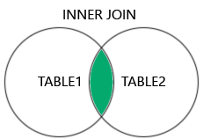
Syntax
The basic syntax of SQL Inner Join is as follows:
SELECT column_name(s)
FROM table1
INNER JOIN table2
ON table1.column_name = table2.column_name;
Example:
We will apply an INNER JOIN using the Employees and Departments tables. This query will retrieve information about employees along with the name of their departments:
SELECT Employees.EmployeeID, Employees.EmployeeName, Departments.DepartmentName
FROM Employees
INNER JOIN Departments
ON Employees.DepartmentID = Departments.DepartmentID;
Joining Multiple Tables Using Inner Join
We can also join multiple tables using Inner Join by specifying the conditions for each join. The syntax is as follows:
SELECT column1, column2, column3...
FROM table1
INNER JOIN table2
ON condition_1
INNER JOIN table3
ON condition_2
...
INNER JOIN tableN
ON condition_N;
Note that even in this case, only two tables can be joined together on a single condition. This process is done sequentially until all the tables are combined.
Example:
We will apply an INNER JOIN to join all three tables (Employees, Departments, and Salaries), retrieving employee details, their department names, and their salaries.
SELECT Employees.EmployeeID, Employees.EmployeeName, Departments.DepartmentName, Salaries.Salary
FROM Employees
INNER JOIN Departments
ON Employees.DepartmentID = Departments.DepartmentID
INNER JOIN Salaries
ON Employees.EmployeeID = Salaries.EmployeeID;
Inner Join with WHERE Clause
Clauses in SQL serve the purpose of applying constraints while retrieving data using SQL queries. Various clauses can be used to constrain the data, such as the WHERE clause, GROUP BY clause, ORDER BY clause, UNION clause, etc.
The WHERE clause is used to filter data from tables by specifying a condition to retrieve only those records that satisfy it.
Inner Join uses the WHERE clause to apply additional constraints on the data to be retrieved. For instance, while retrieving the employee records of an organization, if we only want to check the data of employees earning more than 25,000 in a month, we need to specify a WHERE condition (salary > 25000) to retrieve only those employee records.
Syntax
The syntax of Inner Join when used with the WHERE clause is given below:
SELECT column_name(s)
FROM table1
INNER JOIN table2
ON table1.column_name = table2.column_name
WHERE condition;
Example:
We will apply an INNER JOIN with a WHERE clause. This will retrieve employee details and their department names, but it will filter the results based on a specific condition, such as employees with a salary greater than 55000.
SELECT Employees.EmployeeID, Employees.EmployeeName, Departments.DepartmentName, Salaries.Salary
FROM Employees
INNER JOIN Departments
ON Employees.DepartmentID = Departments.DepartmentID
INNER JOIN Salaries
ON Employees.EmployeeID = Salaries.EmployeeID
WHERE Salaries.Salary > 55000;
Outer Join
An Outer Join is used to join multiple database tables into a combined result set that includes all records, even if they don't satisfy the join condition. NULL values are displayed against these records where the join condition is not met. This scenario occurs if the left table (or the first table) has more records than the right table (or the second table), or vice versa.
There are three types of outer joins:
- Left (Outer) Join: Retrieves all records from the first table, matching records from the second table, and NULL values in unmatched rows.
- Right (Outer) Join: Retrieves all records from the second table, matching records from the first table, and NULL values in unmatched rows.
- Full (Outer) Join: Retrieves records from both tables and fills unmatched values with NULL.
The SQL Left Join
Left Join, or Left Outer Join in SQL, combines two or more tables where the first table is returned entirely, but only the matching record(s) are retrieved from the consequent tables. If no records are matched in the consequent tables, the join still returns a row in the result with NULL in each column from the right table.
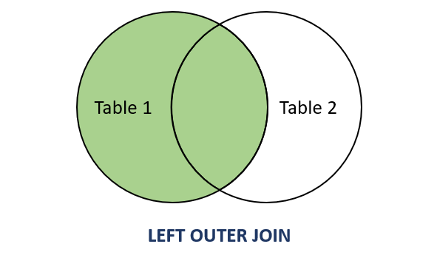
If the number of rows in the first table is less than the number of rows in the second table, the rows in the second table that do not have any counterparts in the first table will be discarded from the result.
Syntax
The basic syntax of Left Join in SQL is as follows:
SELECT column_name(s)
FROM table1
LEFT JOIN table2
ON table1.column_name = table2.column_name;
Example:
Let's apply a LEFT JOIN between the Employees and Departments tables using the basic syntax you've provided. A LEFT JOIN will return all rows from the Employees table, even if there is no match in the Departments table. If there is no match, the result will show NULL for the DepartmentName.
SELECT Employees.EmployeeID, Employees.EmployeeName, Departments.DepartmentName
FROM Employees
LEFT JOIN Departments
ON Employees.DepartmentID = Departments.DepartmentID;
Joining Multiple Tables with Left Join
Similar to the Inner Join query, Left Join can also join multiple tables. The first table is returned as is, and the remaining tables are matched with rows in the first table. If the records are not matched, NULL is returned.
The syntax to join multiple tables using Left Join is as follows:
SELECT column1, column2, column3...
FROM table1
LEFT JOIN table2
ON condition_1
LEFT JOIN table3
ON condition_2
...
LEFT JOIN tableN
ON condition_N;
Example:
To apply a LEFT JOIN on all three tables (Employees, Departments, and Salaries), we can join them sequentially using the provided syntax.
This will return all rows from the Employees table, with matching rows from the Departments and Salaries tables. If a match is not found in either of the joined tables, NULL will be returned for the unmatched columns.
SELECT Employees.EmployeeID, Employees.EmployeeName, Departments.DepartmentName, Salaries.Salary
FROM Employees
LEFT JOIN Departments
ON Employees.DepartmentID = Departments.DepartmentID
LEFT JOIN Salaries
ON Employees.EmployeeID = Salaries.EmployeeID;
Left Join with WHERE Clause
Along with the ON clause, a WHERE clause can also be applied to the obtained result set after a Left Join is implemented. This further filters the data.
Syntax
The syntax of Left Join when used with a WHERE clause is as follows:
SELECT column_name(s)
FROM table1
LEFT JOIN table2
ON table1.column_name = table2.column_name
WHERE condition;
Example:
To apply a LEFT JOIN with a WHERE clause on the Employees, Departments, and Salaries tables, we can filter the result set based on a specific condition. For example, let's say we want to filter the results to only include employees who have a salary greater than 55000.
SELECT Employees.EmployeeID, Employees.EmployeeName, Departments.DepartmentName, Salaries.Salary
FROM Employees
LEFT JOIN Departments
ON Employees.DepartmentID = Departments.DepartmentID
LEFT JOIN Salaries
ON Employees.EmployeeID = Salaries.EmployeeID
WHERE Salaries.Salary >= 55000;
The SQL Right Join
The Right Join (or Right Outer Join) returns all rows from the right table and the matched rows from the left table. If there are no matches, the result will still include all rows from the right table, with NULLs in the columns of the left table.
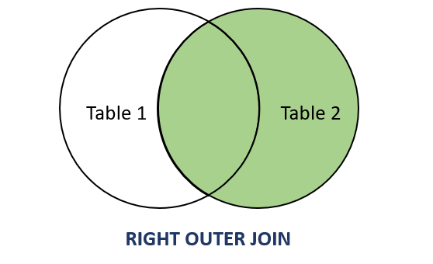
Key Characteristics:
- Returns all records from the right table: Even if there are no corresponding matches in the left table, all records from the right table will be included in the result.
- NULL values for unmatched records: If a record in the right table does not have a matching record in the left table, NULLs will be displayed for the columns of the left table.
Syntax
The basic syntax of the Right Join is as follows:
SELECT table1.column1, table2.column2, ...
FROM table1
RIGHT JOIN table2
ON table1.common_field = table2.common_field;
Example:
To apply a RIGHT JOIN on two tables, we will use the Employees and Departments tables. A RIGHT JOIN returns all rows from the right table (in this case, Departments), and the matched rows from the left table (Employees). If there is no match, NULL will be returned for the columns from the left table.
SELECT Employees.EmployeeID, Employees.EmployeeName, Departments.DepartmentName
FROM Employees
RIGHT JOIN Departments
ON Employees.DepartmentID = Departments.DepartmentID;
Joining Multiple Tables
To join multiple tables using Right Join, follow this syntax:
SELECT column1, column2, ...
FROM table1
RIGHT JOIN table2
ON condition1
RIGHT JOIN table3
ON condition2
...
RIGHT JOIN tableN
ON conditionN;
Example:
To join multiple tables using RIGHT JOIN, we can extend the previous example to include the Salaries table alongside the Employees and Departments tables.
In this scenario, we'll retrieve all departments and their associated employees and salaries, ensuring that all rows from the Salaries table are included, even if there are no matching records in the Employees or Department tables.
SELECT Employees.EmployeeID, Employees.EmployeeName, Departments.DepartmentName, Salaries.Salary
FROM Employees
RIGHT JOIN Departments
ON Employees.DepartmentID = Departments.DepartmentID
RIGHT JOIN Salaries
ON Employees.EmployeeID = Salaries.EmployeeID;
Right Join with WHERE Clause
To filter results based on conditions after a Right Join, use a WHERE clause.
Syntax:
SELECT column_name(s)
FROM table1
RIGHT JOIN table2
ON table1.column_name = table2.column_name
WHERE condition;
Example:
To apply a RIGHT JOIN with a WHERE clause on the Employees, Departments, and Salaries tables, we can filter the results based on specific conditions. For example, let's filter to include only those departments that have salaries greater than 55000.
SELECT Employees.EmployeeID, Employees.EmployeeName, Departments.DepartmentName, Salaries.Salary
FROM Employees
RIGHT JOIN Departments
ON Employees.DepartmentID = Departments.DepartmentID
RIGHT JOIN Salaries
ON Employees.EmployeeID = Salaries.EmployeeID
WHERE Salaries.Salary > 55000;
Note:
- If no employees had salaries above 55000, the result set would be empty, even if departments were present in the Departments table.
- The WHERE clause applies after the join operations, effectively narrowing down the results based on the conditions specified.
The SQL Full Join
Full Join (also known as Full Outer Join) combines all records from two tables, including unmatched records from both sides. For any non-matching rows, it fills in NULL values in place of missing data. This join is a type of outer join that effectively merges the results of both a Left Join and a Right Join.
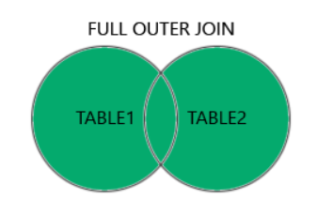
Key Characteristics:
- Includes All Records: Every record from both tables is included in the result set.
- NULL for Non-Matches: When there are no matches for a record in one of the tables, the result will contain NULL for columns of that table.
- Used for Comprehensive Data Analysis: Useful in scenarios where complete data from both sources is needed, even if some relationships do not exist.
Important Note:
MySQL does not support the FULL OUTER JOIN syntax. Instead, you can achieve similar results by combining LEFT JOIN and RIGHT JOIN using a UNION.
Syntax
The basic syntax for a Full Join is as follows:
SELECT column_name(s)
FROM table1
FULL JOIN table2
ON table1.column_name = table2.column_name;
Emulating Full Join in MySQL
Since MySQL doesn't support FULL JOIN, you can replicate it by combining the results of LEFT JOIN and RIGHT JOIN:
SELECT ID, NAME, AMOUNT, DATE
FROM CUSTOMERS
LEFT JOIN ORDERS ON CUSTOMERS.ID = ORDERS.CUSTOMER_ID
UNION
SELECT ID, NAME, AMOUNT, DATE
FROM CUSTOMERS
RIGHT JOIN ORDERS ON CUSTOMERS.ID = ORDERS.CUSTOMER_ID;
Example:
To perform a FULL JOIN in SQL, we can simulate this functionality using a combination of LEFT JOIN and RIGHT JOIN with a UNION operator, especially since MySQL does not support the FULL OUTER JOIN syntax directly.
SELECT Employees.EmployeeID, Employees.EmployeeName, Departments.DepartmentName
FROM Employees
LEFT JOIN Departments
ON Employees.DepartmentID = Departments.DepartmentID
UNION
SELECT Employees.EmployeeID, Employees.EmployeeName, Departments.DepartmentName
FROM Employees
RIGHT JOIN Departments
ON Employees.DepartmentID = Departments.DepartmentID;
The SQL Cross Join
An SQL Cross Join produces the Cartesian product of two tables. This means that every row from the first table is combined with every row from the second table, resulting in a dataset where the number of rows is the product of the number of rows in the two tables.
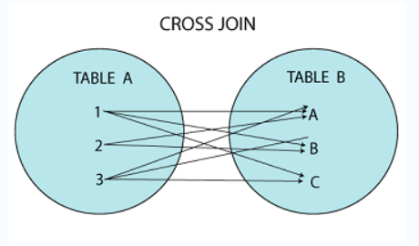
Understanding Cartesian Product:
- A Cartesian product is the result obtained when all possible combinations (or pairs) of rows from two or more sets (tables) are formed.
- For instance, if Table A has 3 rows and Table B has 4 rows, a Cross Join will yield 3 × 4 = 12 rows in the result set.
Syntax
SELECT column_name(s)
FROM table1
CROSS JOIN table2;
Example:
Applying cross join on Employees and Departments Tables.
SELECT Employees.EmployeeID, Employees.EmployeeName, Departments.DepartmentName
FROM Employees
CROSS JOIN Departments;
Joining Multiple Tables
You can also join more than two tables using Cross Join. Each additional table adds more combinations to the result.
Syntax for Multiple Cross Joins:
SELECT column_name(s)
FROM table1
CROSS JOIN table2
CROSS JOIN table3
....
CROSS JOIN tableN;
Example:
To apply a CROSS JOIN on all three tables—Employees, Departments, and Salaries—we will combine every row from each table. This will produce a Cartesian product that includes all possible combinations of rows from the three tables.
SELECT Employees.EmployeeID, Employees.EmployeeName, Departments.DepartmentName, Salaries.Salary
FROM Employees
CROSS JOIN Departments
CROSS JOIN Salaries;
Key Points:
- Use Cases: Cross Joins can be useful in scenarios where you need to explore all combinations of data, like generating reports or creating test cases.
- Performance Consideration: Since Cross Joins can produce a very large number of rows, be cautious about performance and use them judiciously, especially with large datasets.
The SQL Self Join
A Self Join is a type of join that combines records of a table with itself, allowing comparison between rows within the same table.
For illustration, let's consider a scenario where an organization is organizing a Secret Santa event, and each employee has a color assigned. The organization wants to match employees with their Secret Santa based on these color assignments.
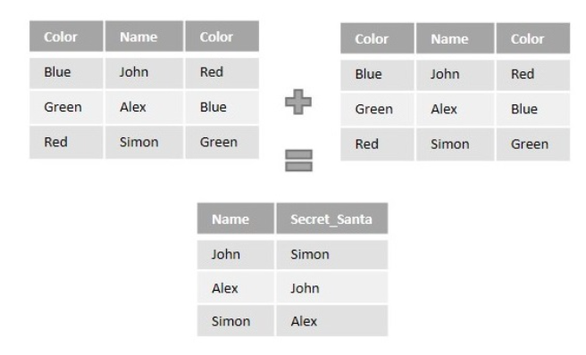
Syntax
Following is the basic syntax of SQL Self Join −
SELECT column_name(s)
FROM table1 a, table1 b
WHERE a.common_field = b.common_field;
Here, the WHERE clause could be any given expression based on your requirement.
Example:
We will use the following SQL query to perform a Self Join to find employees that belong to the same department:
SELECT a.EmployeeID AS EmployeeID1, a.EmployeeName AS EmployeeName1,
b.EmployeeID AS EmployeeID2, b.EmployeeName AS EmployeeName2,
a.DepartmentID
FROM Employees a, Employees b
WHERE a.DepartmentID = b.DepartmentID AND a.EmployeeID <> b.EmployeeID;
Self Join with ORDER BY Clause
To sort the results, we can use the ORDER BY clause.
SELECT column_name(s)
FROM table1 a, table1 b
WHERE a.common_field = b.common_field
ORDER BY column_name;
Example:
To perform a Self Join on the Employees table while incorporating the ORDER BY clause, we can sort the results based on employee names or any other column of interest. In this case, let's sort the output by EmployeeName1.
SELECT a.EmployeeID AS EmployeeID1, a.EmployeeName AS EmployeeName1,
b.EmployeeID AS EmployeeID2, b.EmployeeName AS EmployeeName2,
a.DepartmentID
FROM Employees a, Employees b
WHERE a.DepartmentID = b.DepartmentID AND a.EmployeeID <> b.EmployeeID
ORDER BY a.EmployeeName;
Key Points:
- Self Join uses an alias for the table (e.g., a and b) to differentiate between the two instances of the same table.
- It typically involves comparing rows based on a condition specified in the WHERE clause.
- The output can provide insights into relationships within the same dataset, such as salary comparisons or other criteria.
The SQL DELETE JOIN
The DELETE operation in SQL allows for the removal of one or more records from a database table. When it comes to deleting records from multiple tables simultaneously, SQL provides a method to do so using JOIN clauses. This approach simplifies the deletion process by combining records from related tables based on common fields.
Purpose of DELETE JOIN
- Efficiency: Rather than issuing separate DELETE commands for each table, you can delete records across multiple tables in a single query.
- Data Integrity: Helps maintain referential integrity by ensuring related records are removed together.
Syntax
The syntax for performing a DELETE operation using JOIN is as follows:
DELETE table_alias
FROM table1 AS alias1
JOIN table2 AS alias2
ON alias1.common_field = alias2.common_field;
- table_alias: Represents the table from which the records are to be deleted.
- table1 and table2: These are the tables you are joining.
- common_field: This is the column shared between the tables used to establish the relationship.
Example:
To demonstrate the DELETE JOIN operation on the Employees and Departments tables, we need to establish a scenario where we can delete records based on a condition related to both tables. For example, we can delete employees from the Employees table based on their department, or we can delete a department and all its associated employees.
Scenario
Assume we want to delete all employees who belong to a specific department (for instance, the department with DepartmentID = 3), and we will also delete that department from the Departments table.
-- First, delete employees associated with the department
DELETE e
FROM Employees AS e
JOIN Departments AS d ON e.DepartmentID = d.DepartmentID
WHERE d.DepartmentID = 3;

-- Then, delete the department itself
DELETE FROM Departments WHERE DepartmentID = 3;
DELETE JOIN with WHERE Clause
You can also apply conditions to the DELETE operation by adding a WHERE clause.
Example:
For instance, if you want to delete customers with a salary less than Rs. 2000.00.
To apply a DELETE JOIN operation with a WHERE clause in SQL, you can specify the conditions for which records should be deleted from the joined tables. Below is an example of how to delete records from the Employees table based on a salary condition from the Salaries table.
DELETE e
FROM Employees AS e
JOIN Salaries AS s ON e.EmployeeID = s.EmployeeID
WHERE s.Salary < 2000.00;
Important Note
- Always make sure to back up your data or execute such commands in a safe environment to prevent accidental data loss.
- You can run a SELECT statement with the same JOIN condition to see which records will be affected before running the DELETE command.
The SQL UPDATE... JOIN
The UPDATE statement in SQL allows you to modify existing records in a table. When changes need to be made to data in multiple tables simultaneously, the UPDATE... JOIN clause is utilized to facilitate cross-table modifications.
Purpose
- Update records in multiple tables based on a relationship between them.
- Modify related data that is spread across several tables.
Syntax
UPDATE table1
JOIN table2 ON table1.join_column = table2.join_column
SET table1.column1 = value1,
table1.column2 = value2;
- table1: The primary table being updated.
- table2: The secondary table that is joined with the primary table.
- SET: Specifies the columns to be updated with new values.
Example
Let's use the same Employees and Salaries tables as before, where we want to update the salary of employees based on their department.
UPDATE Salaries AS s
JOIN Employees AS e ON s.EmployeeID = e.EmployeeID
SET s.Salary = s.Salary * 1.10
WHERE e.DepartmentID = 2;
The UPDATE... JOIN operation is a powerful tool for maintaining data integrity and ensuring consistency across related tables in a relational database. It enables updates to be executed across multiple tables with ease and can incorporate filtering conditions through the WHERE clause.

